Discussion saved here onTuesday 17th February 2017. 1 Day viewings of a Meme Picture on Broccoli versus Flesh steak piece protein comparison. 104 Comments, 1215 Shares. 1.6k LIKES/NOTICED.

Go Vegan Revolution added a new photo.
Yesterday at 2:17am ·

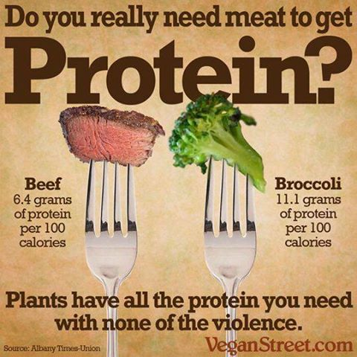

Top of Form
Like
Bottom of Form
Comment
Share
Top Comments
1.6K Fabiha Bushra and 1.6K others
1,215 shares
104 Comments

Noelle Obcarskas 8 cups of brocoli = 2 cups of flesh meat or plant tempeh/seitan/tofu. Got there ! this picture is misleading. http://vegan-information.com/Vegan_Protein_Where_do_you... I did the research and calcuations. Bottom line is ? we are NOT at risk of PROTEIN DEFICIENCY we are FAT ! that is the new problem in the Western World ! and the Wrong sort of FAT ! ...well I managed to finish my WHERE DO I GET MY PROTEIN page. and realised..."With the traditional Western diet, the average American consumes about double the protein her or his body needs." No real danger of a Protein Deficiency ! my daily 2 small packets of peanuts is OUT ! I am getting fat again from too much protein lol ! just did the calculations of some AWEFUL meme used in Go Vegan Revolution discussion yesterday...a big POLEMIQUE of confusion..and I realised...the PICTURE was misleading. In brief...turns out...8 cups of Brocoli to 2 cups of Steak be it Tempeh or Dead Animal is the same amount of protein. So ? we are NOT going to eat 8 cups of Brocoli a day as a norm unless we do a casserole. However ! eating normally, even 1 veganegg sandwich has 10 grams of the 40 grams protein per day average an adult needs ! Our modern problem is...EXCESS protein which turns to FAT rather than Protein Deficiency ! 54 percent of the UK are currently overweight...57percent of Londoners ! and all this EXCESS protein causes major health problems ! so. I was FED UP with lack of even an excel spreadsheet with the list of Foods with Protein grams in sortable descending order...amazing...NO ONE has done one of those ! so I have to do one I have decided
Like · Reply · Just now
Noelle Obcarskas and the problem with this BAD meme is...it does not help anyone with practical vision of what is equal or in proportion to what. It does not show HOW MANY GRAMS OF STEAK versus/compared to HOW MANY GRAMS OF BROCOLI are needed to have the 100 calories OR the grams of protein ! so the meme is TOTALLY useless ! bad show !
Like · Reply · 1 · 13 hrs
Write a reply...

Noelle Obcarskas to look at that picture...it sure implies the SIZE of how much brocoli one needs to eat compared to the SIZE of a piece of flesh is as per the picture proportions ! TOTALLY MISLEADING !
Like · Reply · 13 hrs
Noelle Obcarskas http://www.pcrm.org/.../how-can-i-get-enough-protein-the... "With the traditional Western diet, the average American consumes about double the protein her or his body needs."
Like · Reply · 17 hrs
Carl Smuttsi Åhlin You sure will get enough protein without meat but that picture is very misleading and I don't know why it keeps being posted. 100 calories is a lot of broccoli, more than a normal person would eat. Lentils are a better source of protein.
Unlike · Reply · 77 · Yesterday at 5:05am

4 Replies · 8 hrs

Louis Fitch Have you seen how much broccoli that actually is? Awful infographic! Also I'm veggie so no bias towards meat!

Lele Unainai Exactly.
Like · Reply · 50 mins
Write a reply...

Nicky Hunt 2 big bowls of broccoli vs 3 mouthfuls of steak
Like · Reply · 13 mins
Write a reply...

Christine Murphy 3 cups broccoli has about 11.1 gm protein. 3 ounces of meat has 25 grams of protein.
Unlike · Reply · 9 · 10 hrs

Hide 12 Replies

Noelle Obcarskas good to get realistic comparisons yes. i shall take this meme out of my comparisons/heath examples now ! this any better ?

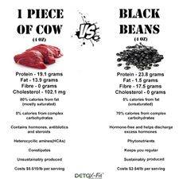

Like · Reply · 3 · 6 hrs
Noelle Obcarskas

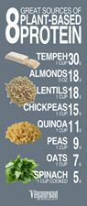

Like · Reply · 2 · 6 hrs
Noelle Obcarskas pomegranate protein meme but not quantified

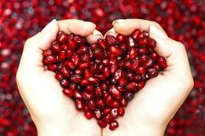

Like · Reply · 6 hrs
Noelle Obcarskas must look at these memes again...i quantified...a cup of almonds in breakfast cereals could have 35 grams of protein average adequate protein needs of an adult per day

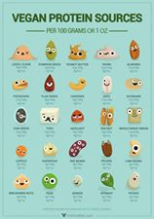

Like · Reply · 2 · 6 hrs
Noelle Obcarskas

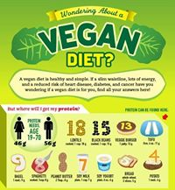

Like · Reply · 1 · 6 hrs
Noelle Obcarskas

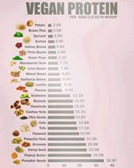

Like · Reply · 1 · 6 hrs
Noelle Obcarskas oh deary me...i need a special WHERE DO I GET MY PROTEIN page lol...

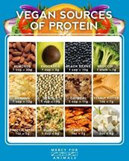

Like · Reply · 1 · 6 hrs
Noelle Obcarskas

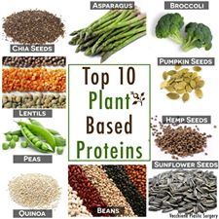

Like · Reply · 1 · 6 hrs
Noelle Obcarskas this is far too vague also

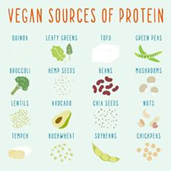

Like · Reply · 1 · 6 hrs
Noelle Obcarskas catn see details on this one..

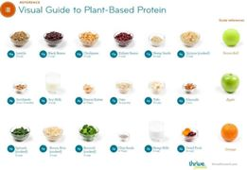

Like · Reply · 1 · 6 hrs
Noelle Obcarskas right this is starting point lol...lets get more PRECISE with the numbers hey...this has to be sorted...TODAY ! David Jack James Hin Chun Chui Rehana Sara Jomeen must go look up Dr Neal Barnard, M.D. pages...surely we can get to...1 cup of almonds on cereals is 35grams average adult protein needs per day ?

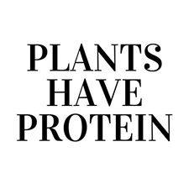

Like · Reply · 1 · 6 hrs
Noelle Obcarskas Overall...as i just say to anyone so far with this issue..spending all day to get protein needs like a monkey probably does as the last person said to me....I say...the problem today isnt LACK of protein looking at the fat state of you...but TOO MUCH lol

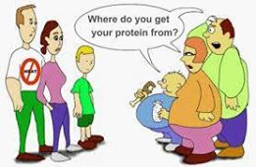

Like · Reply · 1 · 6 hrs
Write a reply...

Richard Gregory I like brocoli but have yet to find one that tastes as good as beef..sorry I will eat brocoli but as a side dish with me medium rare T-bone
Like · Reply · 2 · 56 mins
Nicholas Ristigian Have you seen 100 calories of broccoli as opposed to meat.... youd gave to eat so much broccoli as oppose to steak...
Like · Reply · 6 · 9 hrs
Bronston Keliipuleole In order to get my daily protein needs, which is 120g according to my charts. I would have to consume around 56 cups of broccoli. Does that have to be raw?
Like · Reply · 2 hrs
Hank Drysdale

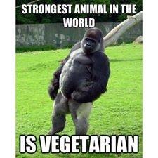

Unlike · Reply · 15 · 10 hrs
Istrel Monroy And is dead:v
Like · Reply · 8 hrs
Noelle Obcarskas now i agree...that he is all muscle...but...he spends ALL DAY EATING i was told when i told some FAT HUMAN protein is in plants...so ? we need to quantify the WHERE DO I GET MY PROTEIN issue better...Hin Chun Chui David Jack James the fact most westerners are OBESE has escaped their notice ! it is now the new NORMAL ! and they squeel WHERE DO YOU GET YOUR PROTEIN ? ref veganism !

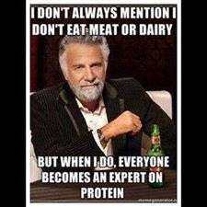

Like · Reply · 5 hrs
Write a reply...

Anthony Sinclair Stacie Jade love a gid chunk q protein. No good for the handbag tha lol
Like · Reply · 4 hrs
Nicky Hunt i have a problem with this ! steak is 25g protine per 100g meat and broccoli is 2.8g per 100g. so a 3 ounce steak vs 2 whole broccoli.
Like · Reply · 16 mins
Christy Grenon Matt Gray I was talking about plant protein earlier, thought this would put it in perspective somewhat
Like · Reply · 4 hrs
Johnny Giannika What about vitamin B12 ?
I need to find that. Can someone help out with some advice ?
Like · Reply · 9 hrs

Hide 12 Replies

Deidre Elliott Nutritional yeast that's fortified, b12 vitamins, b12 shot. Some foods are fortified with it.
Like · Reply · 1 · 9 hrs
Kelvin Ring Vitamin B12 comes from the soil & spring water. If you eat fruit & vegetables from vitamin deficient soil then you should sorce your food better. I've been Vegan for many years & my B12 is fine.
Like · Reply · 3 · 9 hrs
Johnny Giannika Sweet !
Like · Reply · 7 hrs
Johnny Giannika Sweet !
Like · Reply · 7 hrs
Karina Rivadeneira Lots of cereals and nuts milk are fortified with B12
Like · Reply · 6 hrs · Edited
Noelle Obcarskas right well i buy engvita nutritional yeast...turns out it is a deficiency of ALL of us not just vegans.

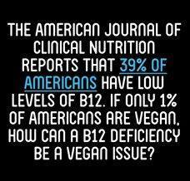

Like · Reply · 5 hrs
Noelle Obcarskas tv is on about deficiency i VITAMIN D right now in the uk...the sunshine one...it never ends !
Like · Reply · 5 hrs
Noelle Obcarskas u never get a cold or the flu if you take VITAMIN D supplements tv is saying !
Like · Reply · 5 hrs
Noelle Obcarskas right...this conversation gets put on one of my webpages ! any objections ? a speical WHERE DO I GET MY PROTEIN page...even one added called WHERE DO YOU GET YOUR PROTEIN page ! in this website lol...loads of iinfo memes needed...must take THIS meme OUT or edit it to say...A WHEELBARROW LOAD Of brococoli...but a CUPFUL of ALMOND NUTS on your breakfast cereal ? is what i wrote guessing but needing to get more precise on...http://vegan-information.com/Health%20Nutritional%20and...
Like · Reply · 5 hrs
Noelle Obcarskas http://vegan-information.com/16114866_10155137185129131... ok ok...looking at that pic closer up...seems to me...a 12 oz TOFU steak a day is plenty PROTEIN per average adult needs of as 3z of tofu gives 8oz of protein i read...so ? 12oz of Tofu would give 34gram of protein...12 oz is the size of a large steak of TOFU . numbers sorted. for TOFU steaks or burgers. Now for the PEANUTS or ALMONDS numbers check and other food items with PROTEIN that an adult can REASONABLY eat in a day regularly withotu grazing like a gorilla...a cup of almonds on cereals seems to me also adquate which is what i wrote. now i eat too many BAKED BEANS tins. STOP for now.

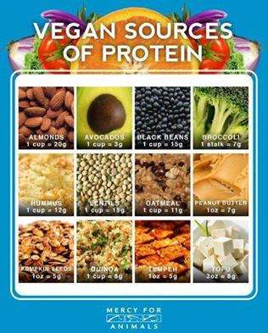
vegan-information.com

Like · Reply · Remove Preview · 5 hrs
Noelle Obcarskas http://vegan-information.com/16142962_10155136966149131...

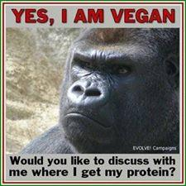
vegan-information.com

Like · Reply · Remove Preview · 5 hrs
Noelle Obcarskas http://vegan-information.com/16196062_10155137103634131...

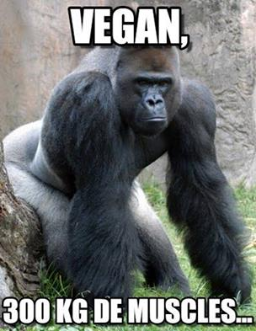
vegan-information.com

Like · Reply · Remove Preview · 5 hrs
Write a reply...

Ahmed Mustafa Labib But the volume of 100 calories of Broccoli =/= the volume of 100 calories of meat.
Like · Reply · 5 hrs
Carmen Carmilla A bulls*t a** myth you do not need meat to live
Like · Reply · 1 · 8 hrs
Brian Fye and the meat tastes soooooooo good!
Like · Reply · 1 · 7 hrs
Brian K Shafer I'm ok with the violence.
Like · Reply · 1 · 6 hrs
Maria Salcido You are an expert at cooking the violence😊😊😊
Like · Reply · 5 hrs
Write a reply...

Rachel Alkire Steve Alkire I will take the broccoli any day :)
Like · Reply · 1 · 8 hrs
Steve Alkire Mmm beef and broccoli, sounds good with some rice :) lol
Like · Reply · 8 hrs · Edited
Sammie McGuire Broccoli does have a small measure of protein, but any meat product has at least 3 times the protein of any vegetable. But I'm with you, broccoli is delish! Yum!
Like · Reply · 6 hrs
Write a reply...

Lae Lly Nui Hau vegan for life bebe ;)
Like · Reply · 1 · 6 hrs
Ray Otsuji Try bbqing broccoli,... Thanks, I'll have a sreak
Like · Reply · 3 hrs
Tampa Tan We need a matrix to show the comparison like this.
Like · Reply · 10 hrs
Callum Vickers Vegans are pussys 🖕🖕🖕👎👎👎
Like · Reply · 3 hrs
Andrey Chiranian To much protein can raise liver enzymes
Like · Reply · 38 mins
Wendy Rossi So many people think otherwise
Sad
Like · Reply · 11 hrs
Constantine Karageorge Tell this to someone who has iron deficiency
Like · Reply · 6 hrs

JoAnne Keils No!!!!!
Like · Reply · 3 hrs
Write a comment...

StatusPhoto/Video

Go Vegan Revolution
February 9 at 5:44pm ·
🌈 Our vegan/cruelty-free Mermaid Brushes are back!! 🐷
You wouldn't want to be the only one not having these..
Have a Look ➡ https://www.goveganrevolution.com/products/mermaid-brushes
... See More

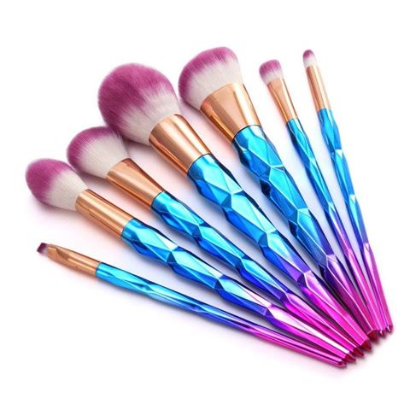

Like

CommentShare
Top Comments
560 560
59 shares

Comments
Write a comment...

Lindsey Louise Decker Yes, I would love to win 😍 they are absolutely beautiful, and even more beautiful knowing they aren't made from animal hair ☺️
Like · Reply · 1 · February 9 at 10:18pm

Felicia Danielle Zapata Yes I Would Love To Win These Cute Brushes... I've Been A Vegetarianism For 5 1/2 Years And This Year I Went Fully Vegan.. Loving It So Far ..
Like · Reply · 2 · February 9 at 7:50pm
2 of 180
View more comments

Go Vegan Revolution added a new photo.
10 hrs ·

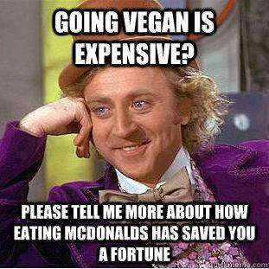

Like

CommentShare
Top Comments
245 245
39 shares

Comments
Write a comment...

Heath Lockett Don't see how maccas has anything to do with eating meat. Nothing in those burgers are truly meat!
Like · Reply · 2 hrs

Marie France Migneault My food bill has reduced since i've become vegan
Like · Reply · 48 mins
View 3 more comments

Go Vegan Revolution added a new photo.
12 hrs ·

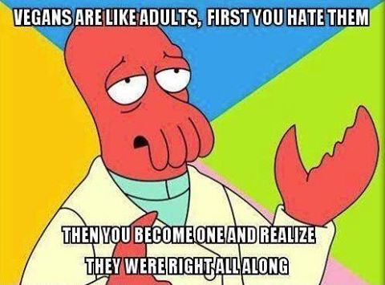

Like

CommentShare
Top Comments
496 496
74 shares

Comments
Write a comment...

Justin Williams Yup. Took me 28 years, but I finally figured it out. It was all so obvious the whole time.
Like · Reply · 2 · 11 hrs

Krysta Libertad Lomeli 👏
Like · Reply · 12 hrs
View 5 more comments

Go Vegan Revolution added a new photo.
14 hrs ·

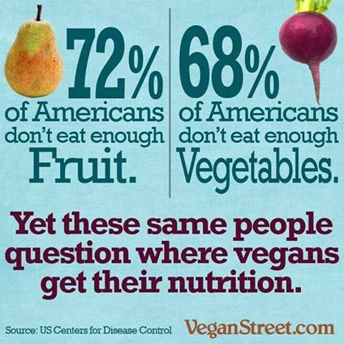

Like

CommentShare
Top Comments
617 617
111 shares

Comments
Write a comment...

Andrey Chiranian That's not even the tip of the ice berg I've been reading, writing , researching everything on health and nutrition n my knowledge shows proof not even my family or friends are coming close to a healthy varied diet. Falling short in every vitamin n mineral recommended amounts, lots of foods including entire food groups being neglected
Like · Reply · 2 · 13 hrs
Andrey Chiranian Look them up individually and the gov has recommended amounts. Or just ask for recommended amounts for vitamins and minerals
Like · Reply · 39 mins
Courteney Clark What are the recommended amounts?
Like · Reply · 1 · 8 hrs
Angi Newsham 🙌🙌🙌
Like · Reply · 13 hrs
Maya Nord Hahaha
Like · Reply · 7 hrs
Sydney O'Brien Billy O'Brien
Like · Reply · 10 hrs
Write a comment...

Courteney Clark What are the recommended amounts?
Unlike · Reply · 2 · 8 hrs
Noelle Obcarskas good question. i am FED Up now of all these EAT 5 OF THIS OR THAT a day gov guidelines on food...with NO details of HOW MANY VITAMINS those oranges etc have ! turns out...a tomato has 5 times LESS nutrients in it today than 40 years ago due to crap gmo etc !!! so ? needs sorting !

